## Project 3

## Integrate grafana with linux server for high cpu utilization and create a graph in grafana.



Table of content

1. Introduction
2. Overview
3. Step by step guide

Introduction

Integrating Grafana with a Linux server to monitor high CPU utilization involves several steps. Here's a clear and practical guide to set this up using Grafana + Prometheus + Node Exporter, which is a common and effective stack for monitoring Linux server metrics.

### ✅ Overview of Steps:

1. **Install Prometheus Node Exporter** on your Linux server (to collect CPU metrics).
2. **Install Prometheus** (or ensure it is already running).
3. **Configure Prometheus to scrape the Node Exporter**.
4. **Install Grafana** and add Prometheus as a data source.
5. **Create a dashboard** in Grafana with a graph for CPU usage.



# Step-by-Step Guide

### Create an EC2 instance

* Login to aws console
* Navigate to EC2
* Click on launch instance

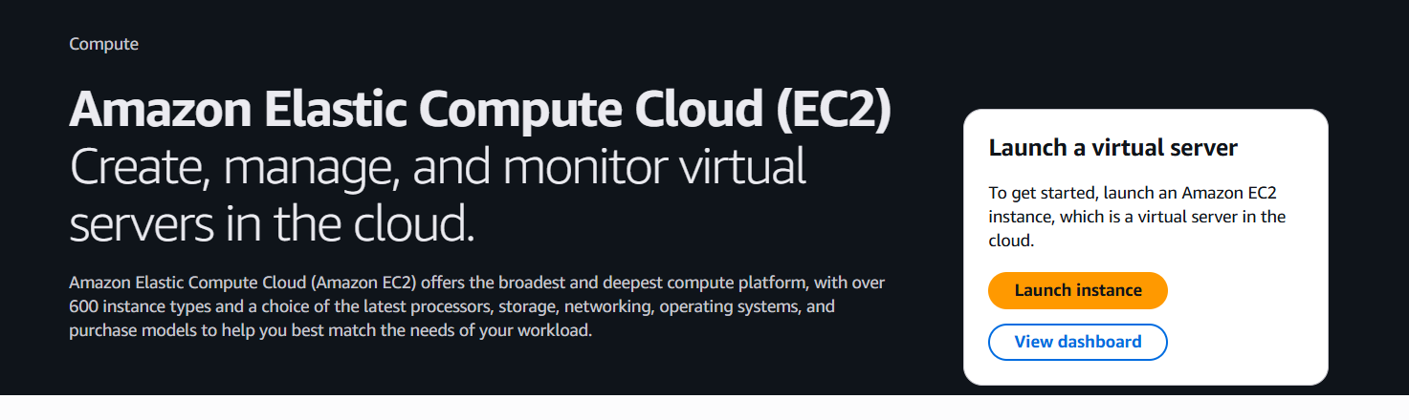

* + **Instance name**: e.g., ec2
  + **Region**: Choose region ap-south1
  + Login as ubuntu
  + Click launch instance

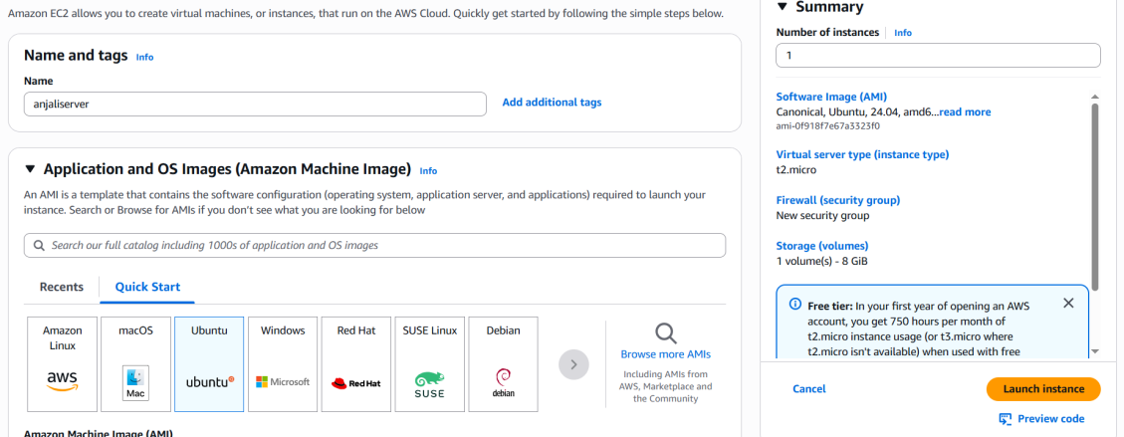

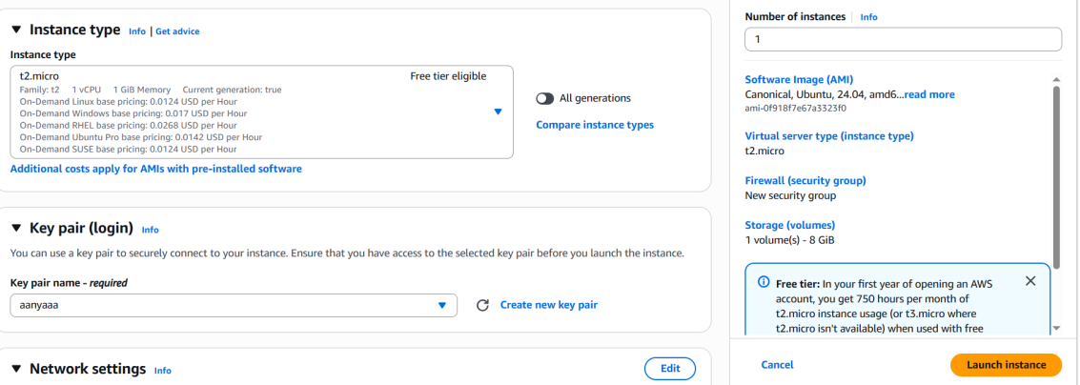

* Now connect with putty
* Login as ubuntu

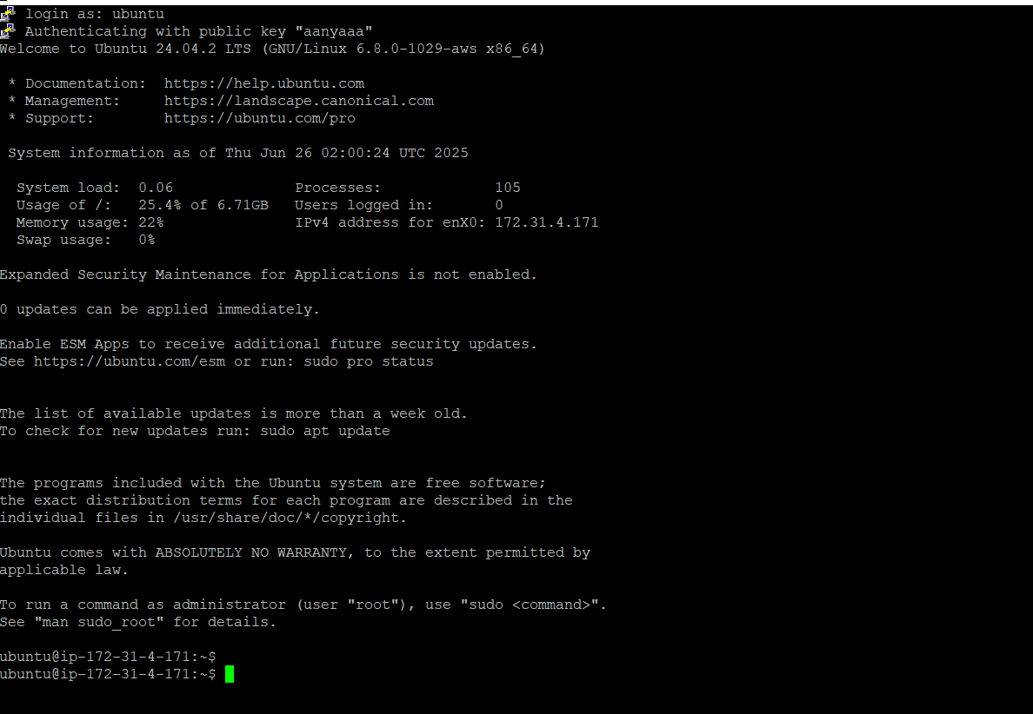

After creating server run the following commands one by one:

* sudo apt update && sudo apt upgrade –y

1 command.PNG

* wget -q -O - https://packages.grafana.com/gpg.key | sudo apt-key add –

2 com.PNG

* echo "deb https://packages.grafana.com/oss/deb stable main" | sudo tee /etc/apt/sources.list.d/grafana.list

3 com.PNG

* sudo apt-get install -y apt-transport-https

sudo apt-get install -y software-properties-common wget

wget -q -O - https://packages.grafana.com/gpg.key | sudo apt-key add -

echo "deb https://packages.grafana.com/oss/deb stable main" | sudo tee /etc/apt/sources.list.d/grafana.list

sudo apt-get update

sudo apt-get install grafana

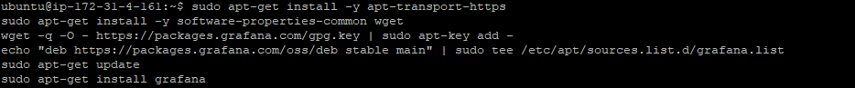

* sudo systemctl daemon-reexec

sudo systemctl start grafana-server

sudo systemctl enable grafana-server

5 com.PNG

* ls /lib/systemd/system/grafana-server.service

6 com.PNG

* sudo apt remove grafana
* sudo apt update
* sudo apt install grafana

7 com.PNG

* sudo apt update && sudo apt upgrade –y

8 com.PNG

9 com.PNG

* echo "deb https://packages.grafana.com/oss/deb stable main" | sudo tee /etc/apt/sources.list.d/grafana.list

10 com.PNG

* sudo apt update

11 com.PNG

* sudo apt install grafana –y

12 com.PNG

* sudo systemctl start grafana-server

13 com.PNG

* sudo systemctl enable grafana-server

14 com.PNG

* sudo systemctl status grafana-server

14 comand.PNG

* Now go to the security group tab of your instance.
* Click on your security group id.
* Click on **edit inbound rules.**

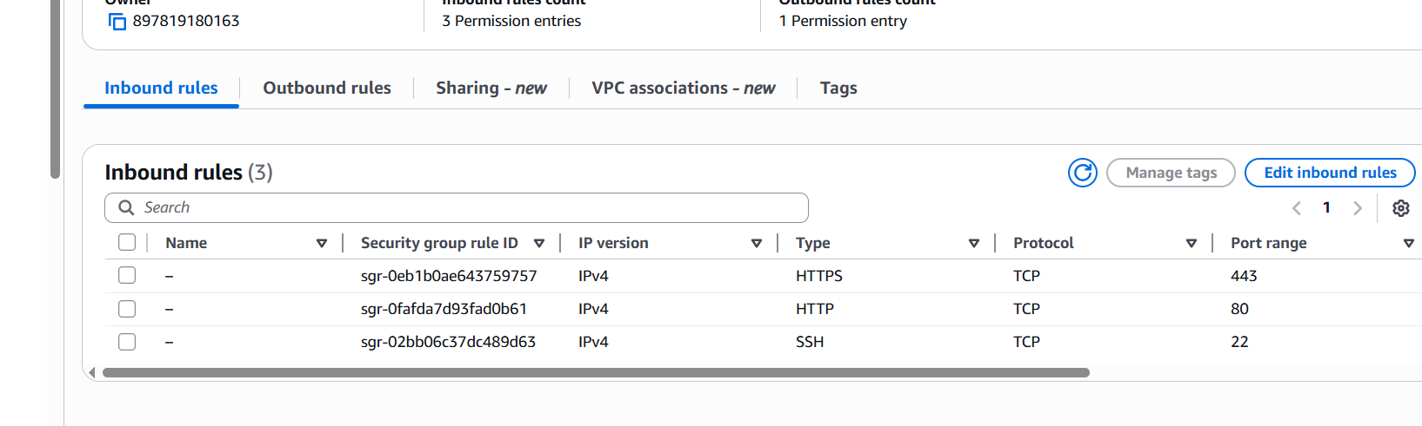

* Click on add rule
* Choose custom TCP,3000 and 0.0.0.0/0 as shown below

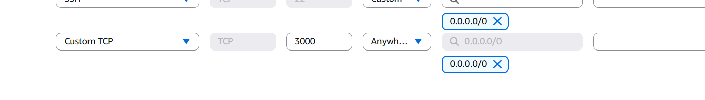

* Copy and paste your public IP with /3000 on goggle Tab Example:-

**Now your Grafana is installed**

* Create username and password as admin and click on log in

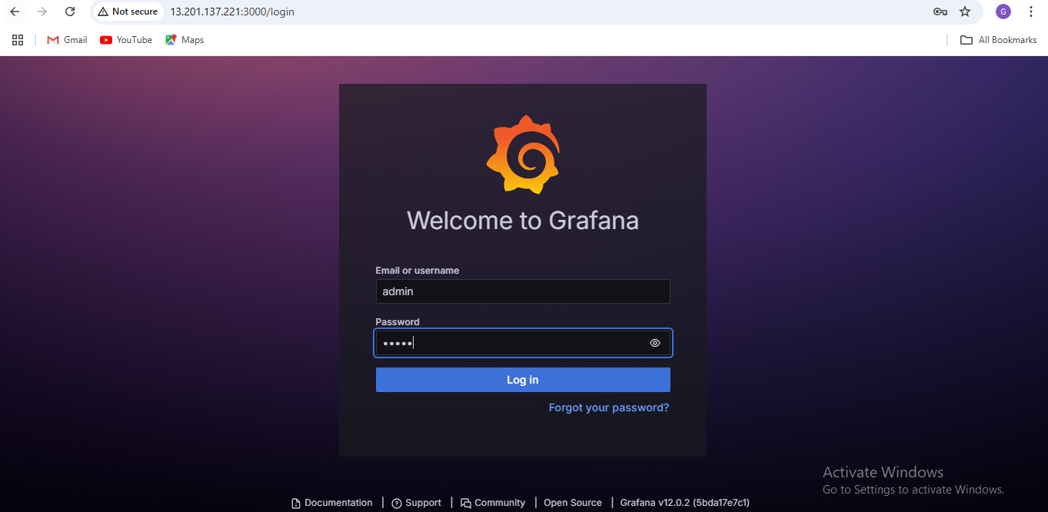

* After this you have to create new password.

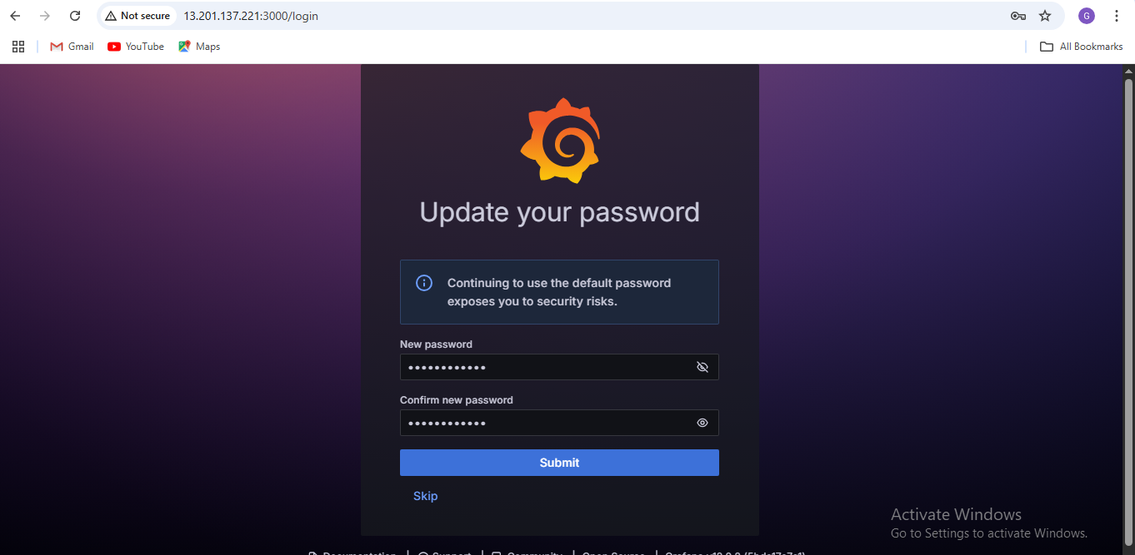

* Now go to the connections and then data source.

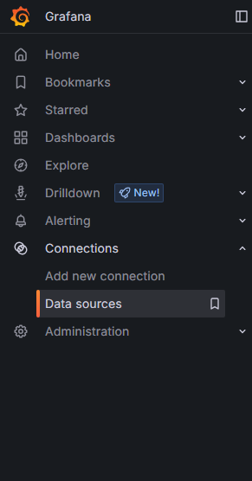

* Click on add data source

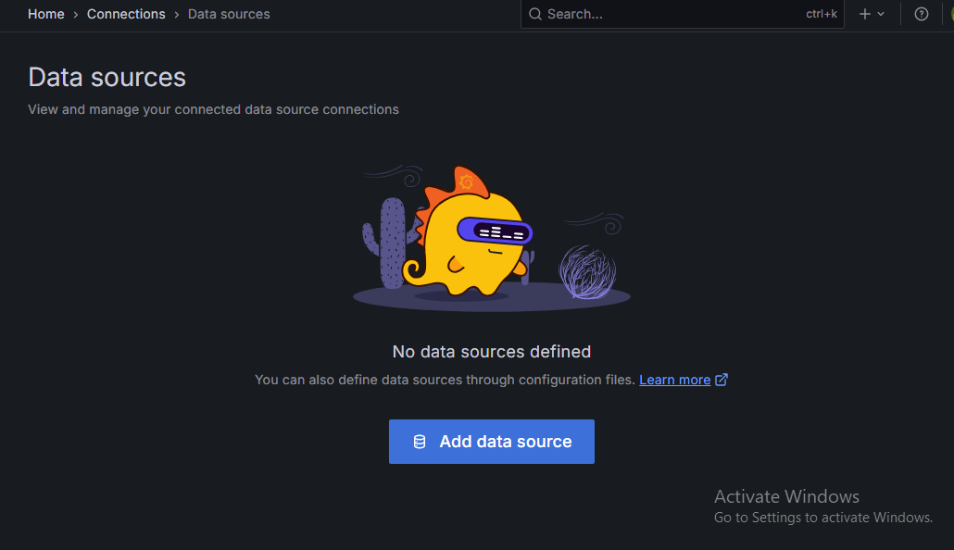

* Search cloud watch on the search panel and select cloud watch.

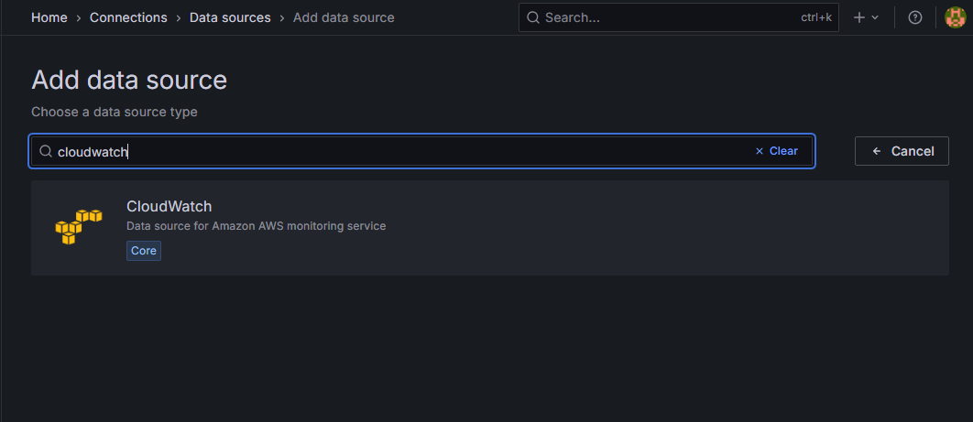

* Now edit connection details

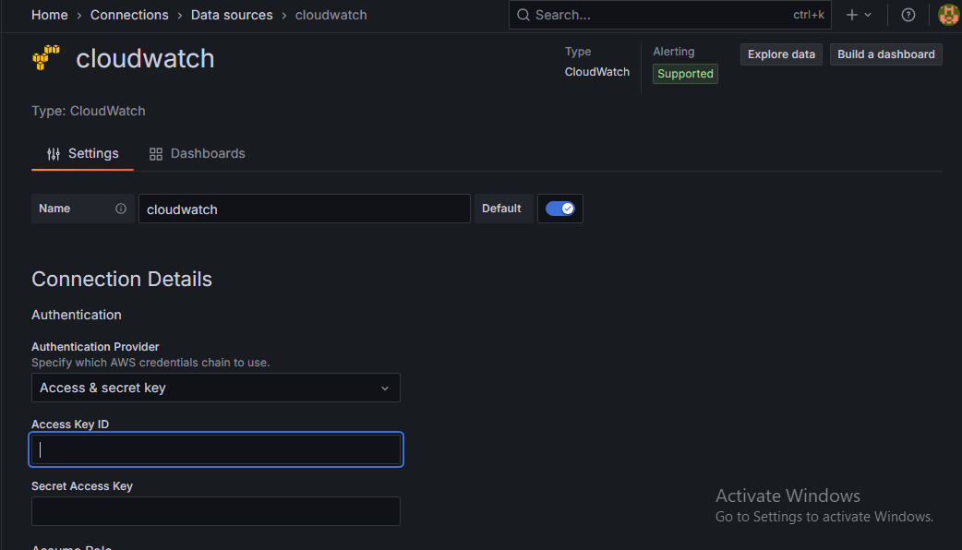

* We have to create Access key
* Now go to IAM and click on user.
* And then create access key.

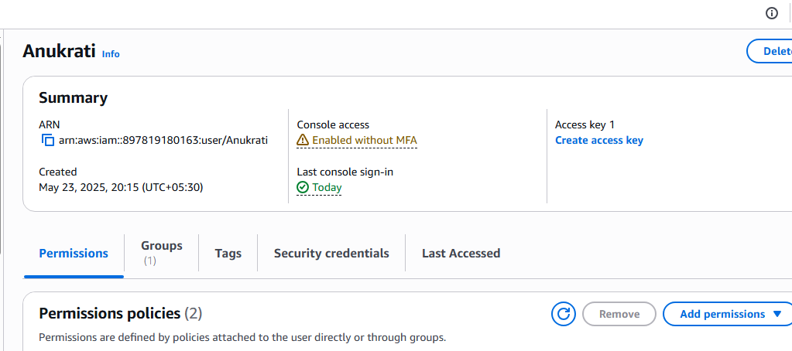

* Click on CLI and then click on next.
* 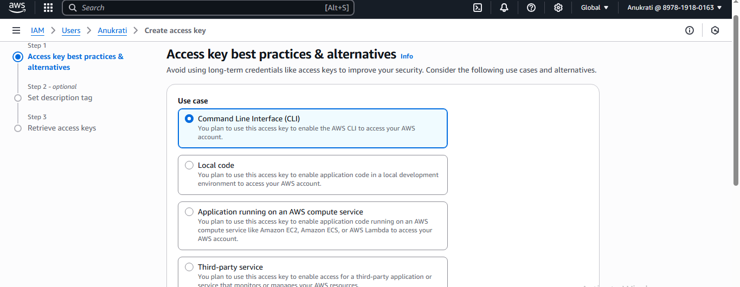Ignore the second step and then mark confirmation and click create access key.

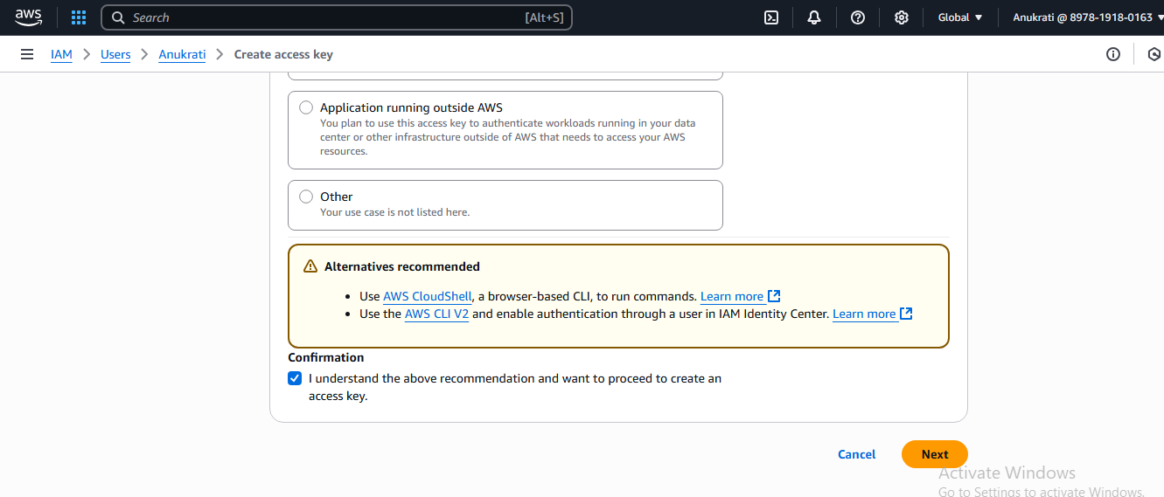

* Your access key is created
* Copy the access key and secrete access key. 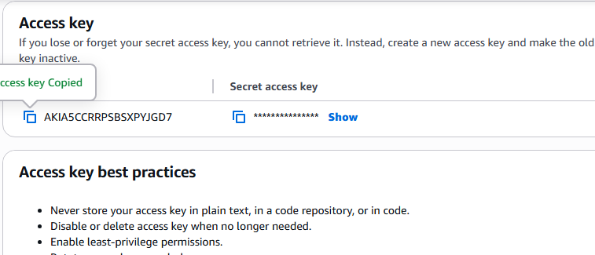
* And paste on the Grafana dashboard.

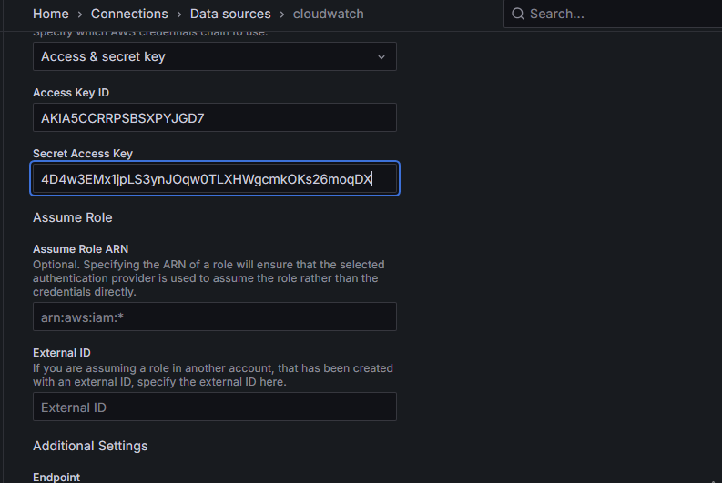

* And select the region ap-south-1

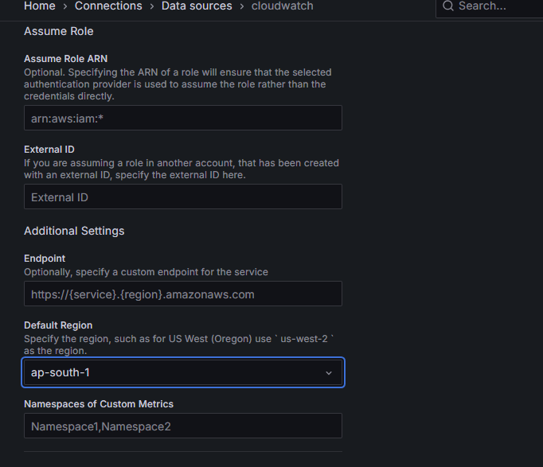

* Then click on save & test.

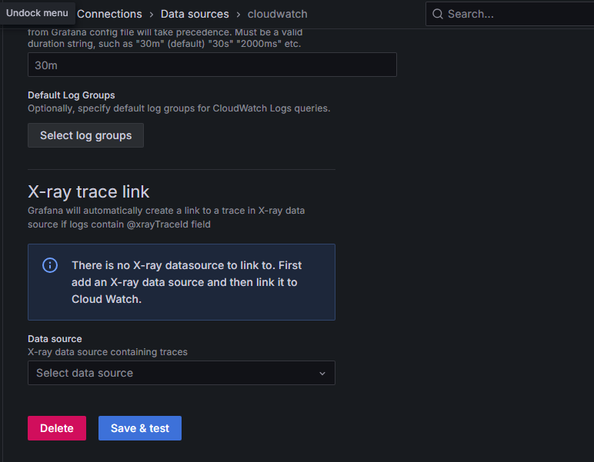

* Go to the dashboard and click on import dashboard.

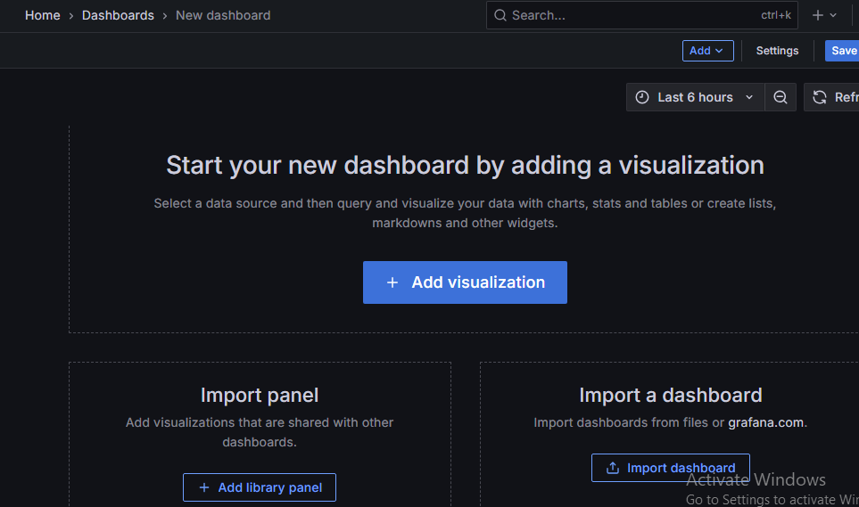

* Search AWS EC2.
* Then copy the id and paste on the dashboard.
* **Now your graph is created**

